Spring 2019 Lifetime Sports Syllabus

TEACHER CONTACT INFORMATION:

Kevin Shaffer Website: http://shaffer42.weebly.com
Email: kshaffer@wcpss.net Phone: (919) 463-8656, extension: 25246
- Units
  - Table tennis Bocce Ball Wiffleball Kickball
  - Badminton Basketball Leisure Sports Fitness
  - Pickle ball Volleyball Bowling
  - Tennis Frisbee Golf Capture the Flag
  - FINAL EXAM

- Weights of grades
  - Major Assessments – 80%
  - Minor Assessments – 20%

- Daily Grade
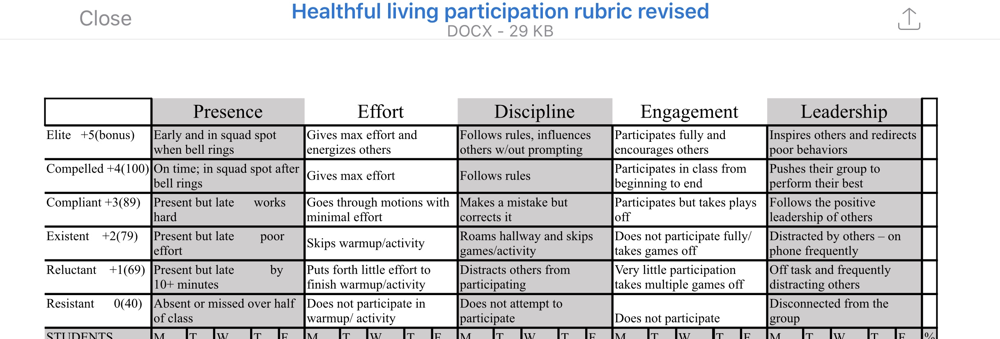
- Absences/Make-up Work
  - Any non-school related absence will need to be made up via SMART Lunch intramurals. Students will receive a zero for the day absent. Upon signing in and completing a SMART Lunch intramural session, all points will be rewarded to the student.
  - SMART Lunch Intramurals are available on the following days:
Weight Room: Mondays & Thursdays A Lunch
Main Gym: Mondays, Tuesdays, Fridays A Lunch
  - Students who do not make up missed work will not be given credit

- Medical / Injury
  - If a student cannot participate due to a medical reason a doctor’s note is required
  - If a student is injured for a length of time they will be provided with an alternate assignment for each day they cannot participate in order to receive full credit for each day.

Student Medical Information Sheet
- The student is able to participate fully in all sports-related activities? YES NO
If no, please explain:_______________________________________________________________________________
________________________________________________________________________________________________
- The student is able to participate in all conditioning related activities? YES NO
If no, please explain:_______________________________________________________________________________
________________________________________________________________________________________________
- Please list any allergies the student has: ________________________________________________________________
________________________________________________________________________________________________
- Are there any conditions/surgeries not addressed above that you would like to make the teacher aware? YES NO
If yes, please explain:______________________________________________________________________________
________________________________________________________________________________________________

By completing the bottom part of this sheet, the student and parent/guardian acknowledges that they understand the procedures, expectations, and grading outlined in the syllabus and will abide by them.

Student’s Name (PRINTED) Student’s Signature

Parent/Guardian’s Name (PRINTED) Parent/Guardian’s Signature
Parent/Guardian Contact Information:
Email:

Preferred Phone Number:
Preferred Method of Communication (please circle one): EMAIL PHONE

