2019-2020 Weight Training and Conditioning Program Syllabus

TEACHER INFORMATION:
Kevin Shaffer Website: http://shaffer42.weebly.com
Email: kshaffer@wcpss.net Phone: (919) 463-8656, extension: 25246

OBJECTIVES:
- Explain, identify and apply biomechanical principles of a variety of lifting techniques. WTC 1 students will learn basic anatomy.
- Demonstrate proper lifting and spotting techniques for all lifts and exercises to ensure personal and group safety.
- Establish and achieve a set of physical fitness goals for health and performance.
- Perform analysis on the techniques of yourself or a classmate while lifting.
- Utilizing the principles of training, create a strength-training and conditioning program.
- Identify the prime mover muscles, antagonistic muscles, and stabilizer muscles for some of the major weight training exercises.
- Understand the importance of, and begin to develop a personal physical fitness log to record workout data on a daily basis.
- Describe the role of intrinsic and extrinsic motivation in physical activity.
- Identify and analyze weight training and fitness activities that enhance personal enjoyment.
- Study and perform higher level Olympic and Auxiliary lifts and integrate them into a training program
- We cover the following concepts: plateau, overload principle, specificity, over training, muscular atrophy, periodization.

ABSENT and SMART LUNCH POLICY: All absences must be made up by attending a Weight Training SMART Lunch (Mondays & Thursdays). Students will receive a zero for any non-school related absences. Full points will be rewarded upon full completion of a Weight Training SMART Lunch session.

Horseplay will not be tolerated in any area. Students misbehaving, or misusing weight room equipment will not be permitted to continue working out during that class session, lose the remainder of that day’s participation points, given lunch detention, administrative referral, and/or parent contact. We are all responsible for each other’s safety, and the upkeep of our equipment!
You are required to dress out daily (bring clothes for both indoor and outdoor activities) in the required attire, and participate in all class activities at your maximum ability.
Students who are injured must bring in a detailed note from a doctor or our athletic trainer explaining the injury and what could be done to rehab the injury. Students will be expected to dress out and lift as long as they will not injure themselves more. A student who cannot lift due to an injury will be given written and / or research assignments during the class period. Parent notes will not be accepted.
We will follow the PCHS Tardy Policy. We will also follow the PCHS Electronics Policy.
Food, gum, and drinks should not be brought into the Weight Room. Water can be kept in the Weight Room Hallway.
Students should obtain teacher’s permission to leave the class. Exceptions will only be made for emergency situations.

GRADING PROCEDURES:
Major Assessment (Student Engagement) – 80%
Students can earn between 20-25 points per day. This includes:
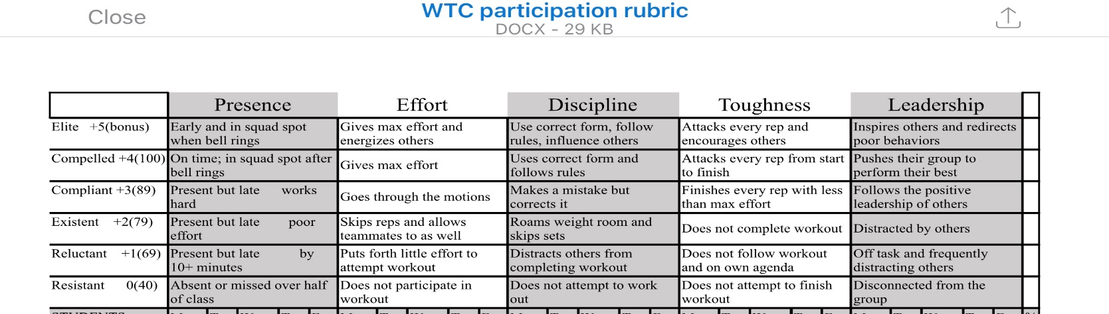

Minor Assessments – 20%
May include, but is not limited to the following: Fitness and MAX out testing, written tests and quizzes, projects, fitness and workout logs, anatomy folders, and written reflections.

* This syllabus is subject to change based upon PLT discretion.

Student Medical Information Sheet

- The student is able to participate fully in all Weight Training activities? YES NO
If no, please explain:________________________________________________________________________________________
_________________________________________________________________________________________________________
- The student is able to participate in all conditioning related activities? YES NO
If no, please explain:________________________________________________________________________________________
_________________________________________________________________________________________________________
- Please list any allergies the student has: ________________________________________________________________________
_________________________________________________________________________________________________________
- Are there any conditions/surgeries not addressed above that you would like to make the teacher aware of? YES NO
If yes, please explain:_______________________________________________________________________________________
_________________________________________________________________________________________________________

By completing the bottom part of this sheet, the student and parent/guardian acknowledges that they understand the procedures, expectations, and grading outlined in the syllabus and will abide by them.

Student’s Name (PRINTED) Student’s Signature

Parent/Guardian’s Name (PRINTED) Parent/Guardian’s Signature

Parent/Guardian Contact Information:

Email:

Preferred Phone Number:

Preferred Method of Communication (please circle one):

Email Phone

